**Front-side of Story Card**

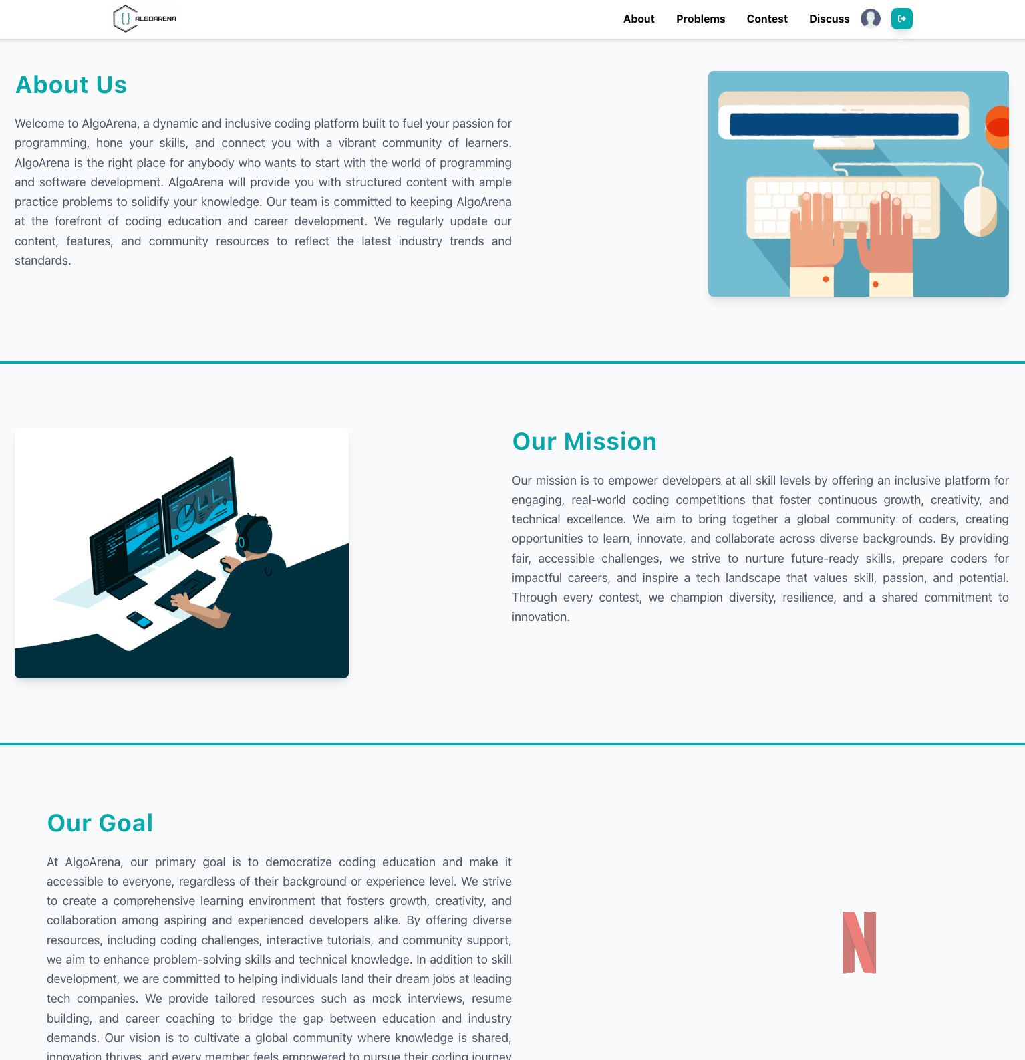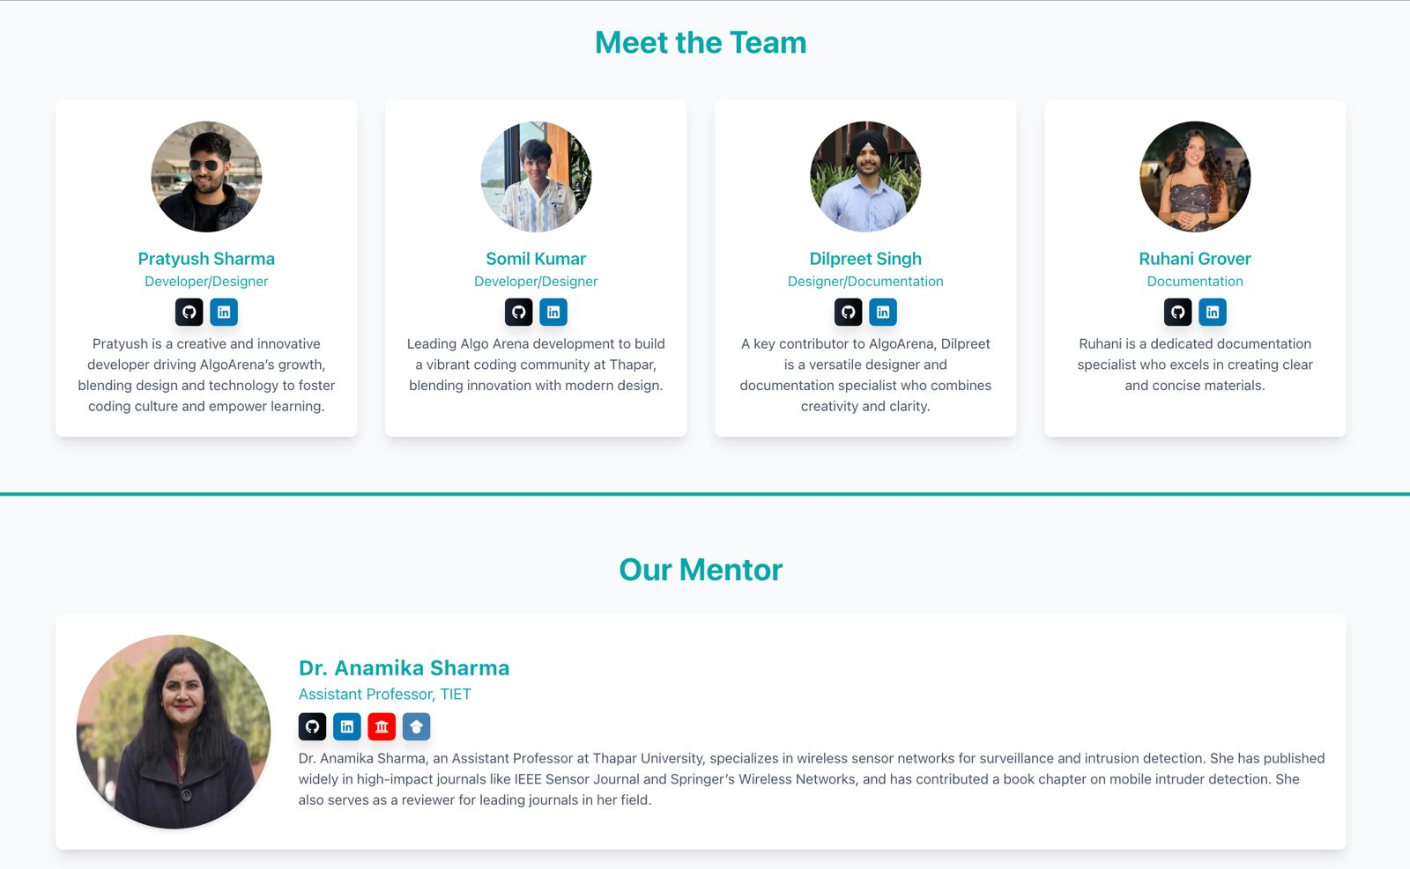

**As a** visitor,

**I want to** view the "About Us" page,

**So that** I can understand the platform's mission, goals, team members, and mentors.

**Backside of the story card**

| Success Conditions   * Mission, goals, and team details (photos and bios) are displayed clearly. * Page loads correctly on all devices.   Failure Conditions   * Information is missing, unclear, or photos fail to load. * Page layout breaks on any device. |
| --- |